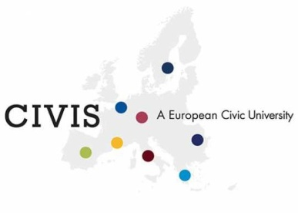



**OPEN ONLINE COURSES – OOC**

**CREDIT RECOGNITION MODULE**

**2021/2022**

This is to certify that the student ……………………………………………..…. born in ………………………………… on ..../..../…., tax/fiscal code …………………….….. matricola n. ………., enrolled in L/LM/PhD in ……………………………….………………………………………………….. has obtained n. ____ credits by passing all exams taken within the Open Online Courses programme, as certified by the enclosed Transcript of Records, issued by the University of ……………………………… in ……………………., during the period from …………………… to …………………… in the frame of the CIVIS Alliance.

The credits earned within the OOC activity will have to be encoded in the following category:

[ ] Free credits to be chosen by the student

[ ] Credits for useful skills to enter the job market

[ ] Credits for extra-curricular activities.

Date:

Name and family name of the project coordinator: ………………………………. Stamp and signature ……………………………………….